

Department of Electronic and Telecommunication Engineering  
University of Moratuwa

EN2160 – Conceptual Design Report  
Morse Code Encoder Decoder

THILAKARATHNE D.L.J. 200650U

This report is submitted as partial fulfilment of the module EN2160 - Electronic Design Realization

6 June 2023

Content

1. Introduction
2. Design Driven Innovation
   1. Conceptual Design
      1. Design – 1
      2. Design – 2
      3. Design – 3
   2. Block Diagrams
      1. Diagram – 1
      2. Diagram – 1
      3. Diagram – 1
3. User Centred Design
   1. Sketch
   2. Block Diagram
4. Evaluation Matrices
   1. Conceptual Designs
   2. Features Update
   3. Block Diagram
   4. Features Update
5. Selected Design
   1. Conceptual Design
   2. Block Diagram
6. Contribution from group members

1. Introduction

The conceptual design phase is a critical stage in the product development cycle, where the design team explores various ideas and prototypes to address specific challenges. During this phase, the team considers different circuits, enclosures, and functional parts, leveraging collective brainstorming sessions to generate innovative concepts. These ideas are then linked to form a comprehensive solution that effectively tackles the identified problem. Through hand sketches, the underlying concepts are organized and presented, aiming to arrive at an optimal solution that fulfils the project objectives. This report outlines the key findings and outcomes of the conceptual design process, highlighting the journey towards the development of an innovative and practical product.

2. Design Driven Innovation

Design-driven innovation is an approach that places design at the forefront of the innovation process, using it as a driving force to generate new and meaningful solutions. It emphasizes the importance of understanding user needs, desires, and behaviours to create products or services that resonate with them. By combining creativity, empathy, and problem-solving, design-driven innovation aims to deliver unique and disruptive outcomes that meet both user expectations and business objectives.

2.a. Conceptual Designs

1. As a cute, fun cube

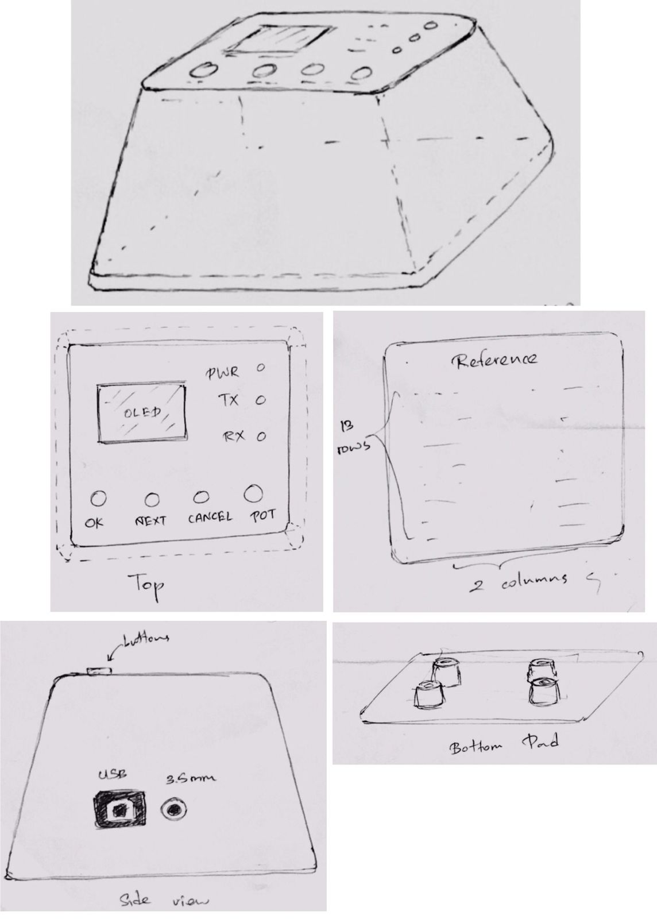



1. As a small gaming station

1. As a Gameboy device (Handheld)

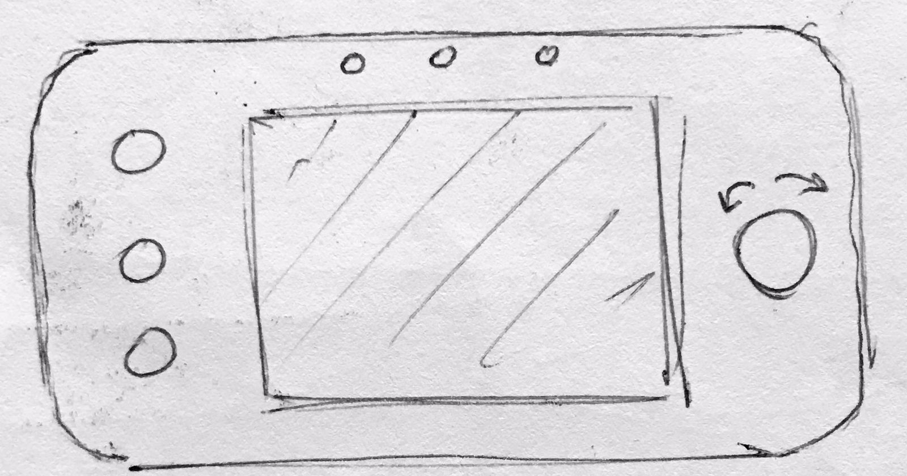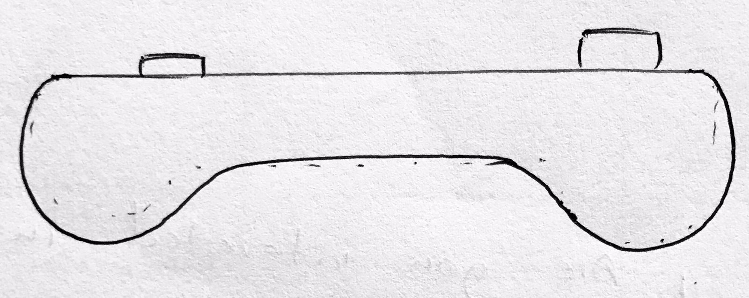

2.b. Block Diagrams

1. Diagram 1

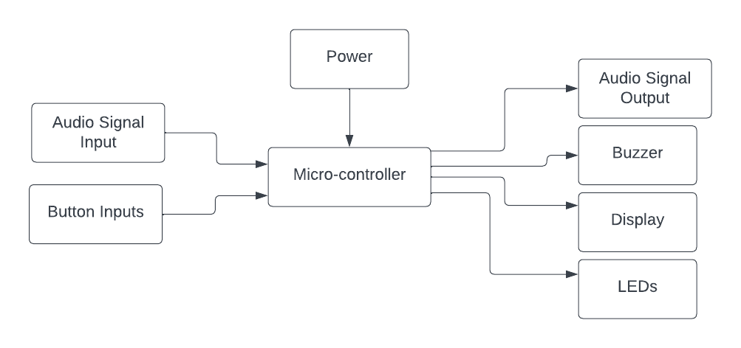

1. Diagram 2

1. Diagram 3

3. User Centred Design

3.a. Sketch

3.b. Block Diagram

4. Evaluation Matrices

4.a. Conceptual Designs

|  |  |  |  |  |
| --- | --- | --- | --- | --- |
| Criterion | Design 1 (Fun Cube) | Design 1 (Gaming Station) | Design 1 (Gameboy) | User Centred Design |
| Aesthetics | 8 | 7 | 8 | 9 |
| Ergonomics | 7 | 5 | 9 | 8 |
| Safety | 8 | 7 | 8 | 8 |
| Durability | 8 | 6 | 5 | 7 |
| Repairability | 7 | 8 | 5 | 6 |
| Simplicity | 8 | 6 | 4 | 8 |
| Portability | 5 | 4 | 6 | 7 |
| Competitiveness | 7 | 8 | 8 | 8 |
| Total | 58 | 51 | 53 | 61 |

4.b. Features Update

|  |  |  |  |  |
| --- | --- | --- | --- | --- |
| Features | Design 1 (Fun Cube) | Design 1 (Gaming Station) | Design 1 (Gameboy) | User Centred Design |
| Added | Simple Aesthetic | Repairability | Ergonomic Aesthetic | Simple Aesthetic |
| Removed | Portability | Aesthetic | Simplicity | Portability |

4.c. Block Diagrams

|  |  |  |  |  |
| --- | --- | --- | --- | --- |
| Criterion | Diagram 1 | Diagram 2 | Diagram 3 | User Centred Design |
| Simplicity | 8 | 8 | 4 | 9 |
| Size | 8 | 6 | 5 | 8 |
| Safety | 6 | 7 | 8 | 8 |
| Durability | 7 | 4 | 9 | 7 |
| Reliability | 7 | 5 | 6 | 7 |
| Efficiency | 6 | 6 | 7 | 7 |
| Scalability | 6 | 6 | 6 | 9 |
| Cost | 7 | 9 | 5 | 8 |
| Total | 55 | 51 | 50 | 63 |

4.d. Features Update

|  |  |  |  |  |
| --- | --- | --- | --- | --- |
| Features | Diagram 1 | Diagram 2 | Diagram 3 | User Centred Design |
| Added | DC Power Simple | Serial Communication | AC Power Tapper | DC Power Simple |
| Removed | Tapper | Tapper | Portability | Tapper |

5. Selected Design

5.a. Conceptual Design

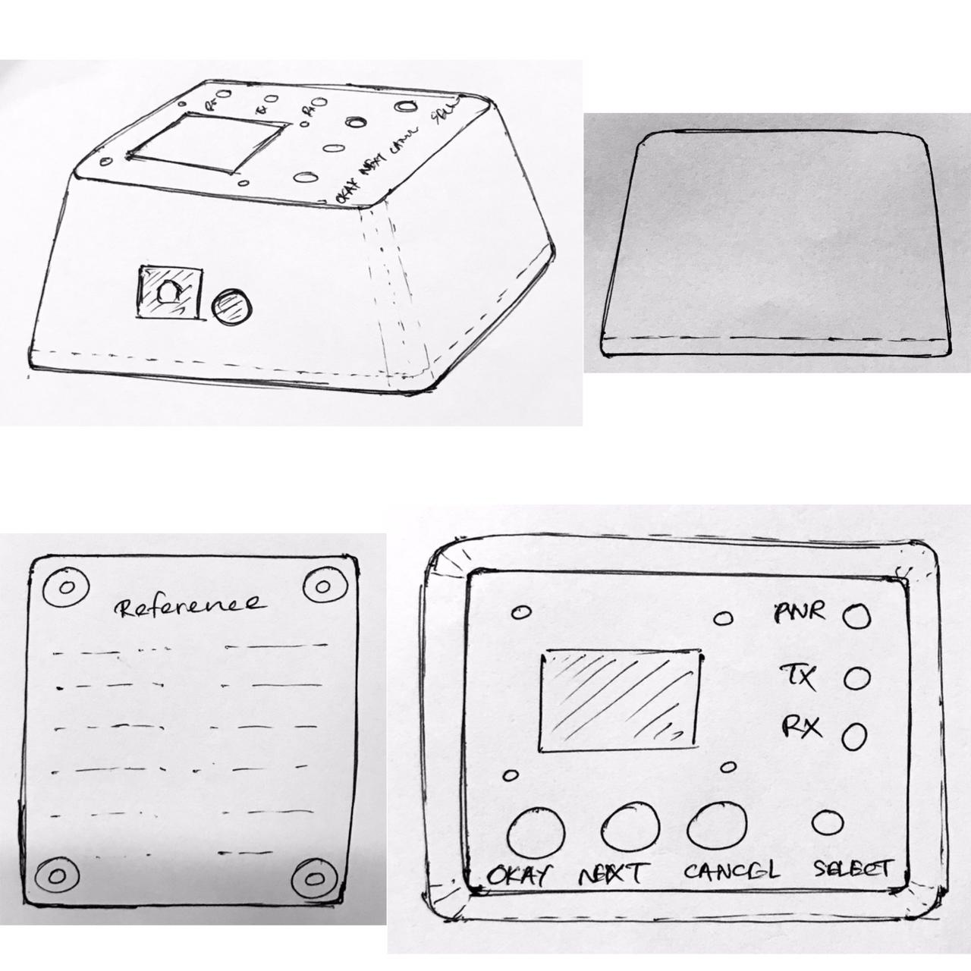

5.b. Block Diagram



6. Contribution from group members

1. Anuki Pasqual – 200445V
2. Tharusha Pathirana – 200449L
3. Navindu Gunawardena – 200201V
4. Peshala Gunathilaka – 200439G
5. Chehal Jayasuriya – 200262G
6. Chamodh Kavinda – 200301D
7. Malanban Kuganenthiran – 200373X

All the members of the group contributed since this was the product that was discussed on the first physical gathering. (On the day where the groups were formed.)